Bangladesh Medical Association (BMA)
List of Life Member-55
19. BMA Gaibandha Branch

Sl No | Voter No | Voter Details
1 | Voter No  LM-1900001  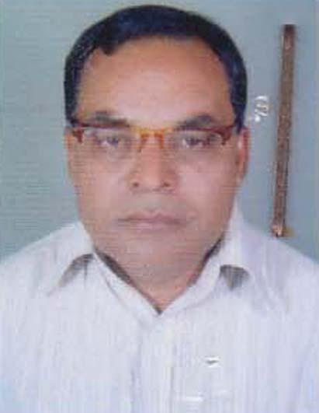 | MD. SHAHIDUZZAMAN  F/Name: Late. Saka-azzaman  M/Name: Latifun Nahar  BM & DC Reg. No: 6757  NID:  Cell: 01712519566  Address: Doctors Pathology, Circular Road, Gaibandha  Blood Group: O+
2 | Voter No  LM-1900002 | DR. MD. NAZRUL ISLAM  F/Name: Mv. Abdus Sabhan Akandaow  M/Name: Loli Nazeron Nessa  BM & DC Reg. No: 7384  NID: 3222405119528  Cell: 01199101680  Address: Civil Surgeon, Baibandha  Blood Group: B+
3 | Voter No  LM-1900003 | DR. MD. ABDUL MALEQUE SARKER  F/Name: Late Yousuf Uddin Sarker  M/Name: Late Kahirun Nasa  BM & DC Reg. No: 6526  NID: 3222406123983  Cell: 01714049405  Address: Dib Road, Gaibandha, Dist- Gaibandha  Blood Group:
4 | Voter No  LM-1900004 | DR. PRODIP KUMAR KARMAKAR  F/Name: Shaheed Jagai Chandra Karmakar  M/Name: Malina Karmakar  BM & DC Reg. No: 8454  NID: 3222401102834  Cell: 01715002135  Address: UHC\'FPO. Sadar. Gaibandha  Blood Group: B+
5 | Voter No  LM-1900005 | DR. A.K.M. SHAMSUZZOHA KHANDAKER  F/Name: Late Abdul Jobbar Khandaker  M/Name: Ms. Jobeda Khatun  BM & DC Reg. No: 8449  NID:  Cell: 01711066301  Address: Sadar Hospital, Road, Gaibandha  Blood Group: B+
6 | Voter No  LM-1900006 | DR. MD. E.K. SHAFIQUE  F/Name: Md. Habibur Rahman  M/Name: Late Sutia. Khalil  BM & DC Reg. No: 44755  NID: 3222404115128  Cell: 01712875301  Address: College Road, Baibandha  Blood Group: A+
7 | Voter No  LM-1900007  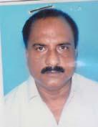 | DR. MD. SHAHJAHAN SARKAR  F/Name: Late Moyez Uddin Sarkar  M/Name: Late Saleha Begum  BM & DC Reg. No: 16062  NID: 3223005611780  Cell: 01716574516  Address: Upazilla Health Complex Gobindoganj, Gaibandha  Blood Group: A+
8 | Voter No  LM-1900008  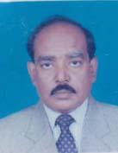 | DR. MD. SHAHADAT HOSSAIN KHANDOKER  F/Name: Late Korban Ali Khandoker  M/Name: Late Alima Khandoker  BM & DC Reg. No: 12140  NID: 3222406126907  Cell: 01712130474  Address: Sarkar Hospital, Gaibandha  Blood Group: O+
9 | Voter No  LM-1900009 | DR. MD. ABDUL JALIL SARDAR  F/Name: Late Refayat Hossain Sardar  M/Name: Late Jobeda Begum  BM & DC Reg. No: 14217  NID: 3222404114989  Cell: 01712223795  Address: Junior Consultant, Chest Diseases Clinic Gaibandha  Blood Group: O+
10 | Voter No  LM-1900010 | DR. AMAL CHANDRA SAHA  F/Name: Late Radha Gobinda Saha  M/Name: Anuyea Bala Saha  BM & DC Reg. No: 15322  NID: 3222407131081  Cell: 01712647621  Address: E.M.O. Sadar Hospital Gaibandha  Blood Group: O+
11 | Voter No  LM-1900011  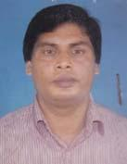 | DR. MD. AMINUL ISLAM  F/Name: Late Abul Hossain Akand  M/Name: Late. Firoza Begum  BM & DC Reg. No: 16676  NID: 3222404116958  Cell: 01191555965  Address: College Road, Dalashpara, Gaibandha  Blood Group: A+
12 | Voter No  LM-1900012  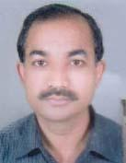 | DR. A.K.M. ASADUZZAMAN  F/Name: Md. Abdul Kaddus Sarker  M/Name: Late Mrs. Amena Khatun  BM & DC Reg. No: 45480  NID: 3222406126198  Cell: 01712288251  Address: MCWC, Madhapara, Sadar Gaibandha  Blood Group: B+
13 | Voter No  LM-1900013  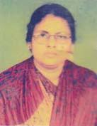 | DR. MST. AFSARY KHANOM  F/Name: Late Azizur Rahman  M/Name: Zohora Rahman  BM & DC Reg. No: 19669  NID: 3222406126196  Cell: 01718881412  Address: MCWC, Sadar, Gaibandha  Blood Group: B+
14 | Voter No  LM-1900014  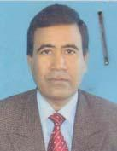 | DR. A.B.M. ABU HANIF  F/Name: Md. Anwar Hossain  M/Name: Late Hamida Khatun  BM & DC Reg. No: 19809  NID: 3222404116961  Cell: 01711077727  Address: Holding # 358, Polash Para, Gaibandha  Blood Group:
15 | Voter No  LM-1900015  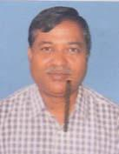 | DR. SHAHABU SYED MOSTAQ AHMED  F/Name: Late Shah Sabed Ali  M/Name: Late Morium Bewa  BM & DC Reg. No: 11858  NID:  Cell: 01712247499  Address: Medical Officer (MCH-FP) Sadar, Gaybandha  Blood Group: O+
16 | Voter No  LM-1900016 | DR. MD. MATIAR RAHMAN  F/Name: Late Mozibor Rahman Prodhan  M/Name: Most. Noslema Khatun  BM & DC Reg. No: 7397  NID: 3222403111760  Cell: 0171221489  Address: Holding no: 410, Dhaxin Danghara D.B Road. Gaibandha  Blood Group: O+
17 | Voter No  LM-1900017 | DR. MD. FERDOUS HOSSAIN  F/Name: Late Nural Hossain Ahmed  M/Name: Begum Fatema Ahmed  BM & DC Reg. No: 10273  NID: 3222406125548  Cell: 01711587767  Address: Vill-Gorosthanpara, Helal Park Road, P.O-Gaibandha, Dist: Gaibandha  Blood Group: O+
18 | Voter No  LM-1900018 | DR. AKRAM HOSSAIN  F/Name: Late Golzer Rahman  M/Name: Fatema Begum  BM & DC Reg. No: 166657  NID: 3222404116351  Cell: 01711077749  Address: College Road, Gaibandha  Blood Group: O+
19 | Voter No  LM-1900019 | DR. SULTAN AHMED  F/Name: Solaiman Miah  M/Name: Suroton Nesa  BM & DC Reg. No: 14876  NID:  Cell:  Address: Spondon, Boalia, Gobindaganj, Gaibandha  Blood Group: O+
20 | Voter No  LM-1900020 | DR. MD. RASHIDUL HASAN  F/Name: Late Abul Hossain  M/Name: Mst. Mahmuda Begum  BM & DC Reg. No: 19043  NID: 3222404116595  Cell: 01552391417  Address: Assistant Professor, Dep. Of Biochemistry, Shaheed Ziaur Rahman Medical College, Bogra  Blood Group:
21 | Voter No  LM-1900021 | DR. MD. RAFIQUZZAMAN  F/Name: Late. Mahbub Hossain  M/Name: Zaeda. Khatun  BM & DC Reg. No: 33963  NID: 3222409127955  Cell: 01720102579  Address: Master Para Gaibandha  Blood Group: A+
22 | Voter No  LM-1900022  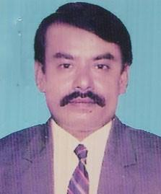 | DR. MD. ABDUS SOBHAN  F/Name: Late Niamot Ullah Pramanik  M/Name: Late Asia Khatun  BM & DC Reg. No: 13516  NID:  Cell: 01712284871  Address: Uh & Epo- Birampur Upazila Dianjpur  Blood Group:
23 | Voter No  LM-1900023  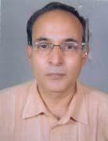 | DR. RAMENDRA NATH SARKER  F/Name: Late, Ramkanta Sarker  M/Name: Late Promila Rani Sarker  BM & DC Reg. No: 16944  NID: 8524902012295  Cell: 01712288463  Address: Junior Consultant (Cordiology) Sadar Hospital, Gaibandha  Blood Group: A+
24 | Voter No  LM-1900024 | MD. ZAHEDI MASUD RUBEL  F/Name: Md. Amirul Islam  M/Name: Most. Rabeya Khatun  BM & DC Reg. No: 51578  NID: 2726411202684  Cell: 01718760900  Address: Gaibandha Sadar, Gaibandha  Blood Group: B+
25 | Voter No  LM-1900025 | MD. ABDUR RAHIM  F/Name: Late Abdul Halim  M/Name: Late Razia Khatun  BM & DC Reg. No: 32473  NID: 7326405194510  Cell: 01823009520  Address: Meri Stopes Maternity Clinic, Gaibandha Sadar, Gaibandha  Blood Group: A+
26 | Voter No  LM-1900026 | DR. MD. SEKENDER ALI  F/Name: Late Helal Uddin  M/Name: Late Dholi Begum  BM & DC Reg. No: 21767  NID: 7326402323077  Cell: 01712919809  Address: MO (MCHFP), Gaibandha Sadar, Gaibandha  Blood Group: A+
27 | Voter No  LM-1900027 | DR. MD. LUTFAR RAHMAN  F/Name: Late Md. Abdul Gafur  M/Name: Mst. Samena Begum  BM & DC Reg. No: 24454  NID: 9329518330605  Cell: 01717798050  Address: Civil Surgeon office, Gaibandha, post & Dist-Gaibandha  Blood Group: A+
28 | Voter No  LM-1900028  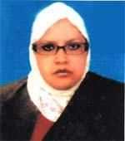 | DDR. MAHBUBA ZAMAN (MINI)  F/Name: Alhazz. Md. Hadiuzzaman  M/Name: Late Mantuza Begum  BM & DC Reg. No: 39433  NID: 8524911135291  Cell: 01744858340  Address: V-Aid Road, Kalibari-para, Gaibandha  Blood Group: A+
29 | Voter No  LM-1900029  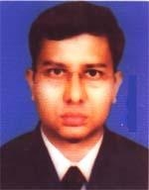 | DR. MAHABUR RAHAMAN SARKER  F/Name: Mojibor Rahaman Sarker  M/Name: Most. Asia Khatun  BM & DC Reg. No: 28220  NID: 2692848062825  Cell: 01712229251  Address: Rabeya Clinic, DB Road, Gaibandha  Blood Group: B+
30 | Voter No  LM-1900030 | DR.DEBASHIS MONDOL ANGKUR  F/Name: Monoranjan Mondol  M/Name: Kallani Rani Mondol  BM & DC Reg. No: 46997  NID: 8198506403732  Cell: 01717516261  Address: Upazilla Health Complex, Fulchari, Gaibandha  Blood Group: A+
31 | Voter No  LM-1900031  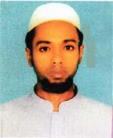 | DR. MD. MOMINUL ISLAM  F/Name: Md. Asmot Ali  M/Name: Mst. Rahima Khatun  BM & DC Reg. No: 64419  NID: 3212135187736  Cell: 01726257599  Address: Upazilla Health Complex, Fulchari, Gaibandha  Blood Group: O+
32 | Voter No  LM-1900032  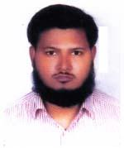 | DR. MD. MASUDER RAHMAN AKANDA  F/Name: Md. Abdur Rahman Akanda  M/Name: Hasina Begum  BM & DC Reg. No: 54380  NID: 2694066798183  Cell: 01723882175  Address: Polash Para, Gaibandha  Blood Group: B+
33 | Voter No  LM-1900033 | DR. S. M. NOOR E SHADID  F/Name: S. M. Nuruzzaman  M/Name: Sharifun Nesa  BM & DC Reg. No: 50054  NID: 3222405381013  Cell: 01712293917  Address: Adarsha College Road, Banglabazar, Gaibandha  Blood Group: B+
34 | Voter No  LM-1900034  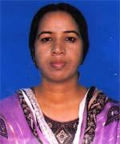 | DR. MOST. TAHERA AKHTER MONI  F/Name: Md. Abdul Jabbar Sarker  M/Name: Most. Hasna Begum  BM & DC Reg. No: 29869  NID: 3222407367071  Cell: 01728581177  Address: Sadar Hospital, Gaibandha  Blood Group: O+
35 | Voter No  LM-1900035 | DR. MD. KHORSED ALAM  F/Name: Md. Abdul Hai  M/Name: Mst. Afruza Begum  BM & DC Reg. No: 50934  NID: 8524904042934  Cell: 0172315110  Address: Sadar Hospital, Gaibandha  Blood Group: O+
36 | Voter No  LM-1900036 | DR. MD. ABDUL KADER  F/Name: Md. Abubakar Siddique  M/Name: Most. Zaheda Khatun  BM & DC Reg. No: 33410  NID: 19753212480165950  Cell: 01712285260  Address: Sapha Para, Gaibandha  Blood Group: AB+
37 | Voter No  LM-1900037  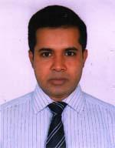 | DR. MD. GOLAM RABBANI  F/Name: Md. Ruhul Amin  M/Name: Mrs. Jahanara Begum  BM & DC Reg. No: 38210  NID: 3216719619885  Cell: 01793592703  Address: 98/1, Bridae Road, Gaibandha  Blood Group: B+
38 | Voter No  LM-1900038  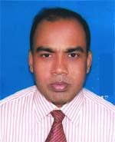 | DR. ABUL AZAD MANDAL  F/Name: Late Sharimuddin Mandal  M/Name: Late Abeda Begum  BM & DC Reg. No: 28354  NID: 2723804750969  Cell: 01721460368  Address: Jr. Consultant, (Paediatrics), 100 Beded District Hospital, Gaibandha  Blood Group: O+
39 | Voter No  LM-1900039 | DR. MD. SHAHINUL ISLAM MONDAL  F/Name: Late Delower Hossain Mondal  M/Name: Most. Selina Begum  BM & DC Reg. No: 49667  NID: 3216785301226  Cell: 01719303748  Address: Vill-Nunehagari, Post-Palashbari, Upazilla-Palashbari, Dist-Gaibandha  Blood Group: O+
40 | Voter No  LM-1900040 | DR. MD. MAHBUBUR RAHAMAN AKANDA  F/Name: Md. Abdur Rahaman Akanda  M/Name: Late Hasina Begum  BM & DC Reg. No: 38972  NID: 3222404114899  Cell: 01712021929  Address: Khandoker X-Ray Clinic, Hospital Road, Gaibandha  Blood Group: B+
41 | Voter No  LM-1900041 | DR. MD. ILTUTMISH AKANDA  F/Name: Late Abul Kasem  M/Name: Begum Halima Kashem  BM & DC Reg. No: 63575  NID: 1595708569617  Cell: 01710229815  Address: Vill-Chandia , Post-Bhabanigonj, P.s-Fulchari, Dist-Gaibandha  Blood Group: B+
42 | Voter No  LM-1900042  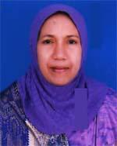 | DR. TAJUN NAHER BEGUM  F/Name: A. T. M. Mostafizur Rahman  M/Name: Monjum Ara Begum  BM & DC Reg. No: 21063  NID: 3222404116352  Cell: 01720690009  Address: College Road, Gaibandha  Blood Group: O+
43 | Voter No  LM-1900043  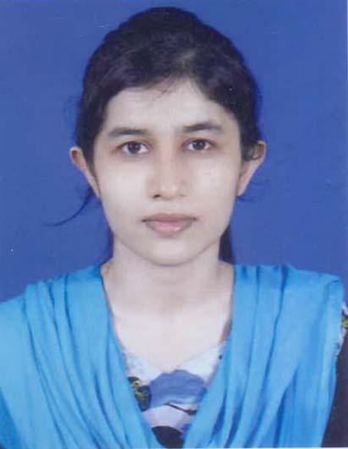 | DR. PRIYAM KARMAKAR  F/Name: Prodip Kumar Karmakar  M/Name: Radha Rani Roy  BM & DC Reg. No: 90402  NID: 9119614528  Cell: 01962159552  Address: House: 506, Station Road, post: Gaibanda, 5700 Gaibanda Sadar, Gaibanda.  Blood Group: B+
44 | Voter No  LM-1900044 | DR. ABHIJEET ROY  F/Name: Anit Kumar Ray  M/Name: Jharna Roy  BM & DC Reg. No: 73593  NID: 5065750230  Cell: 01716017832  Address: House: 731, Villege: Buzrukboalia, post: Gobindogong, 5740, Gaibanda.  Blood Group: O+
45 | Voter No  LM-1900045  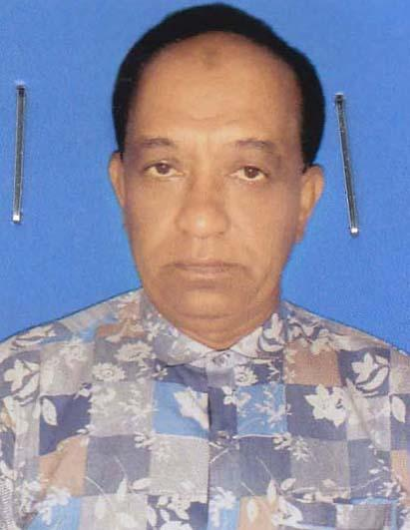 | DR. MD. MORSHED ALAM  F/Name: Late: Jonab Ali  M/Name: Most: Nurtaj Begum  BM & DC Reg. No: 21247  NID: 01322201000006  Cell: 01757819199  Address: AddressAppolo Hospital & Diagnostic Center, Sadar Hospital Road, Gaibanda.  Blood Group: B+
46 | Voter No  LM-1900046  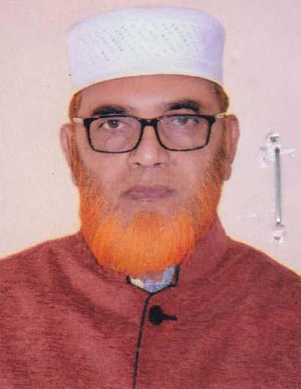 | DR. ABDUR RAHIM SARKER  F/Name: Late: Emam Athy  M/Name: Late: Rabeya Khatun  BM & DC Reg. No: 14148  NID: 3213022778477  Cell: 01760284054  Address: Sapla park, Gaibanda. Blood Group:  Blood Group:
47 | Voter No  LM-1900047  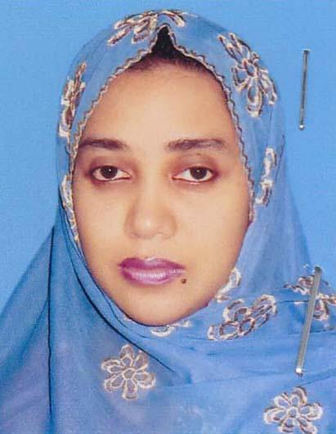 | DR. SUMAYA SADIA  F/Name: Dr. A Rahim Sarker  M/Name: Dr. Shahida Sarker  BM & DC Reg. No: 50585  NID: 2692848062824  Cell: 01717523233  Address: Sapla park, Gaibanda.  Blood Group:
48 | Voter No  LM-1900048  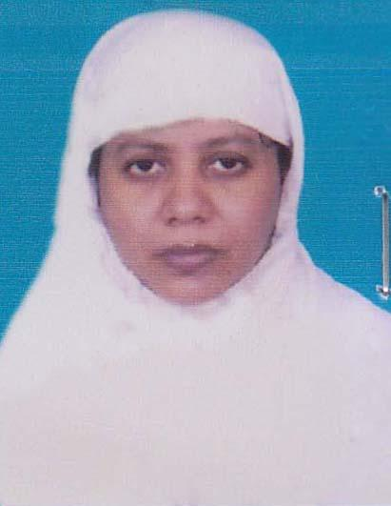 | DR. SHAIDA SARKER  F/Name: Late: Ataur Rahman  M/Name: Feroza Begum  BM & DC Reg. No: 19494  NID: 3222403123870  Cell: 01782866449  Address: Sapla park, Gaibanda  Blood Group: B+
49 | Voter No  LM-1900049  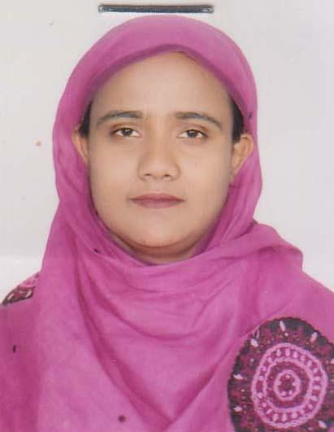 | DR. MST: ISMAT JAHAN  F/Name: Md. Rezaul Alam Khandoker  M/Name: Mrs: Ahasana Alam  BM & DC Reg. No: 41723  NID: 19803222404115667  Cell: 01712933134  Address: Collage Para, Gaibanda.  Blood Group: AB+
50 | Voter No  LM-1900050  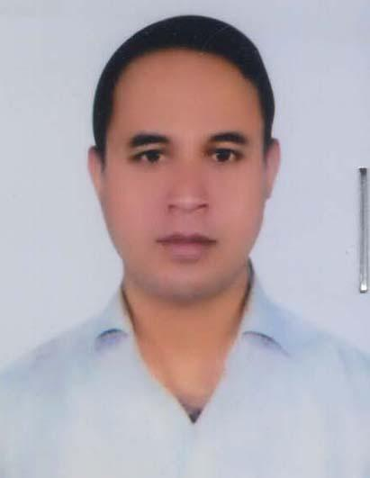 | DR. MD. AYNAL HOQUE  F/Name: Md. Khaybar Hossain  M/Name: Mst. Amena Khatun  BM & DC Reg. No: 42109  NID: 3222404385311  Cell: 01712249065  Address: House-69, Road- 1/2, Thana Para, Gaibanda.  Blood Group: B+
51 | Voter No  LM-1900051 | DR. SUMON KUMAR PRAMANIK  F/Name: Khagendra Nath Pramanik  M/Name: Sunita Rani  BM & DC Reg. No: 66469  NID: 8198510364754  Cell:  Address: House-31, Road- 1/1, Ward no 06, Zilpara, Gobindagong, Gaibanda.  Blood Group: A+
52 | Voter No  LM-1900052  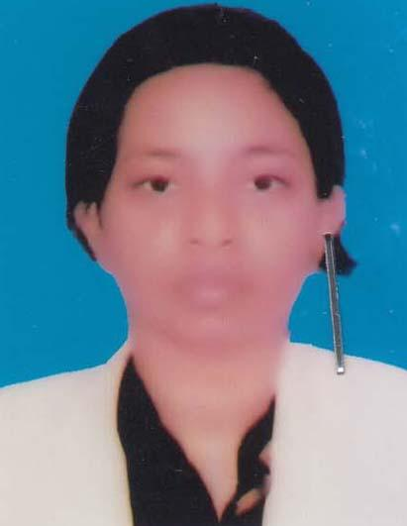 | DR. MASHRUFA REZMIN  F/Name: Dr. Md. Matiar Rahman  M/Name: Mrs: Rozy Rahman  BM & DC Reg. No: 82998  NID: 9574992104  Cell: 01729720732  Address: W/O. TM Rafiul Hasan Anup, Thana para, Gaibanda.  Blood Group: B+
53 | Voter No  LM-1900053  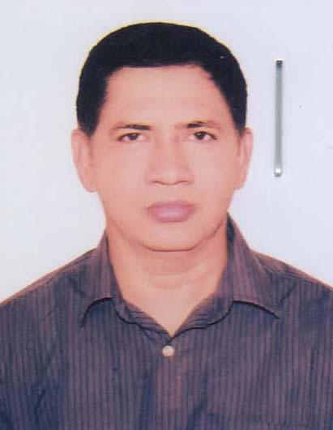 | DR. ATM MOSTAFIZUR RAHMAN  F/Name: Late: Md. Atwar Rahman  M/Name: Mrs: Rowshan Ara Begum  BM & DC Reg. No: 33434  NID: 6424073911  Cell: 01711004827  Address: Bashundhara Ad-Din Medical College Hospital, South Keranigong, Dhaka..  Blood Group: A+
54 | Voter No  LM-1900054  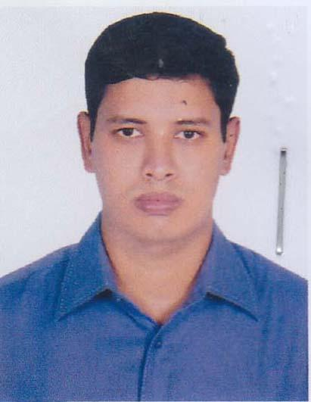 | DR. TANBIR AHMED  F/Name: Rezaul Karim Ahmed  M/Name: Most. Nurun Nahar Begum  BM & DC Reg. No: 42770  NID: 4642698460  Cell: 01714241974  Address: Laxmipur, Tulshighat, Gaibanda  Blood Group:
55 | Voter No  LM-1900055 | DR. PRITOM KARMAKAR  F/Name: Prodip Kumar Karmakar  M/Name: Radha Rani Roy  BM & DC Reg. No: 6809  NID: 7756465337  Cell: 01751678428  Address: Station Road, Natun Bazar, Gaibanda.  Blood Group: B+

